SESMA Martial Arts UK
Coaching Future Champions since 1989

How to Register to the SESMA Members Site

- Type in your website browser top search bar the following: sesma.mymamembers.com
DO NOT PUT “WWW” in front as this will NOT work

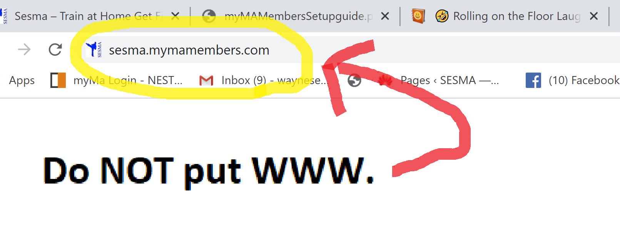
- Click on Register

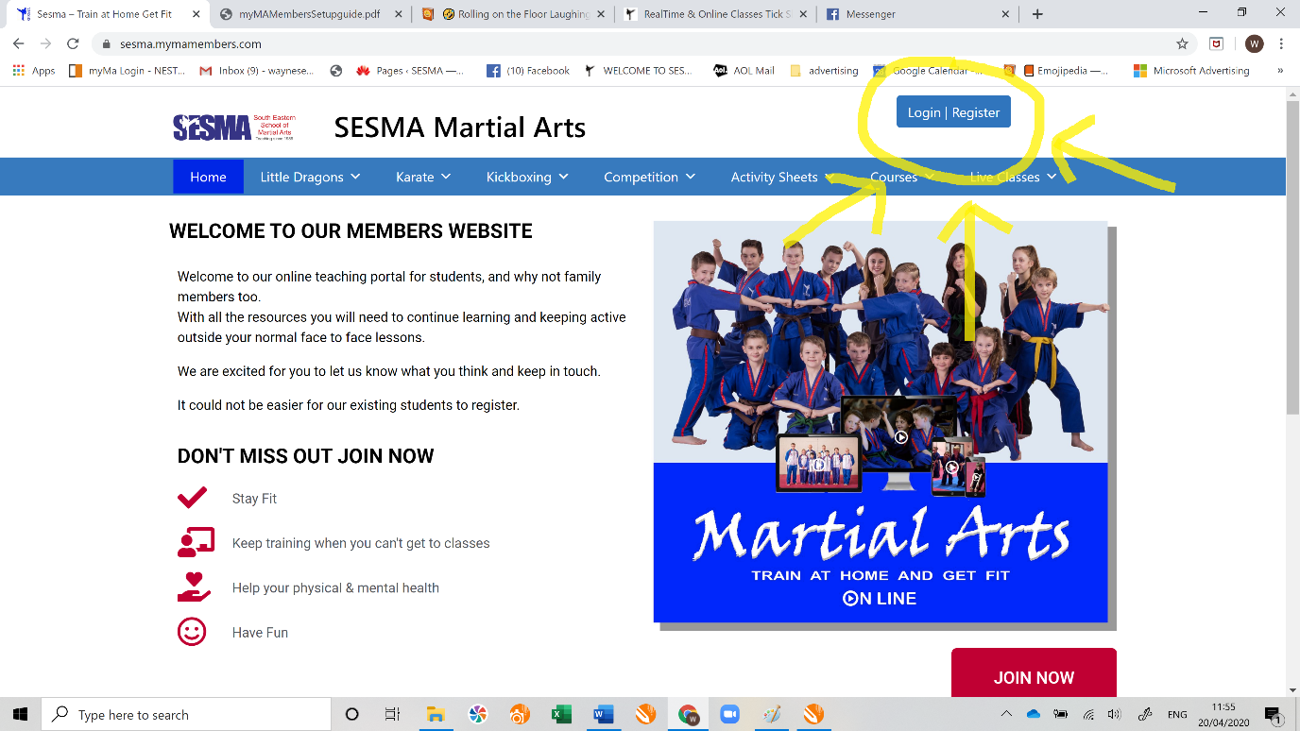

- Fill in your details. You MUST use the email address I have used to send you these details other wise you will not be able to register. The system uses the details you used to become a SESMA member.

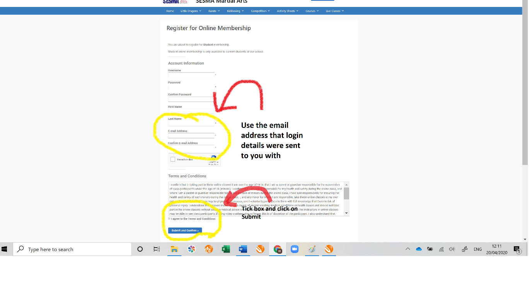
- AUTOMATIC APPROVAL PROCESS
Once students have registered, they will need to be approved before they can access the websites protected content. ACTIVE STUDENTS ON MYMA WILL BE APPROVED AUTOMATICALLY After registering for access, a script runs to confirm whether this is an active student on the NEST myMA system, based on their email address. If an active student exists with that email address, they will be automatically approved within 24 hours of registering. Hence why you use the email address that was used to send you these details.

Depending on your Browser, you could pin the SESMA Members Portal to your
Favourites Bar and save you password. This will make accessing the portal much quicker.

The Members site is regularly updated with videos and activities.

