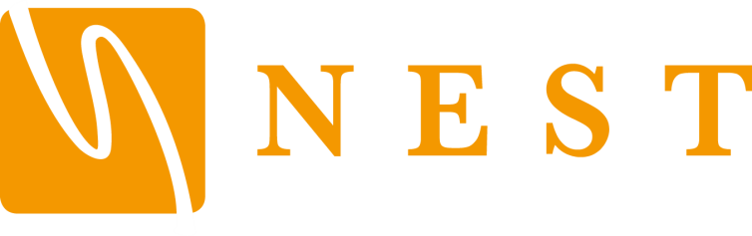

Code of Conduct for Children and Young People
South Eastern School of Martial Arts SESMA is fully committed to safeguarding and promoting the wellbeing of all its members. The club believes that it is important that members, coaches, administrators and parents associated with the club should, at all times, show respect and understanding for the safety and welfare of others. Therefore, members are encouraged to be open at all times and to share any concerns or complaints that they may have about any aspect of the club with Master Wayne Head Senior Instructor

Sports clubs should offer a positive experience for children and young people and where they can learn new things in a safe and positive environment.

As a member of South Eastern School of Martial Arts SESMA, you are expected to abide by the following junior code of practice:

Children and young people are expected to:

- Be loyal and give their friends a second chance.
- Be friendly and particularly welcoming to new members.
- Be supportive and committed to other team members, offer comfort when required.
- Keep yourself safe.
- Report inappropriate behaviour or risky situations for youth members.
- Play fairly and be trustworthy.
- Respect officials and accept decisions.
- Show appropriate loyalty and be gracious in defeat.
- Respect opponents.
- Not cheat or be violent and aggressive.
- Make your club a fun place to be.
- Keep within the defined boundary of the playing/coaching area.
- Behave and listen to all instructions from the coach. Play within the rules and respect the official and their decisions.
- Show respect to other youth members/leaders and show team spirit.
- Take care of equipment owned by the club.
- Respect the rights, dignity and worth of all participants regardless of age, gender, ability, race, cultural background or religious beliefs or sexual identity.
- Refrain from the use of bad language or racial/sectarian references. This includes bullying using new technologies like chat-rooms or texting.
- Not get involved in inappropriate peer pressure and push others into something they do not want to do.
- Refrain from bullying or persistent use of rough and dangerous play.
- Keep to agreed timings for training and competitions or inform their coach or team manager if they are going to be late.
- Wear suitable kit; – for training and match sessions, as agreed with the coach/team manager.
- Pay any fees for training or events promptly.
- Not smoke on club premises or whilst representing the club at competitions.
- Not consume alcohol or drugs of any kind on the club premises or whilst representing the club.

Children / Young People have the right to:

- Be safe and happy in their chosen activity.
- Be listened to.
- Be respected and treated fairly.
- Privacy.
- Enjoy your sport in a protective environment.
- Be referred to professional help if needed.
- Be protected from abuse by other member or outside sources.
- Participate on an equal basis, appropriate to their ability.
- Experience competition and the desire to win.
- Be believed.
- Ask for help.
- Have any concerns taken seriously and acted on.

Any minor misdemeanours and general misbehaviour will be addressed by the coach and reported verbally to the designated person. More serious or persistent misbehaviour may result in disciplinary action and potentially dismissal from the club/sport. Parents will be informed at all stages.

Disciplinary action can be appealed to the coach with final decisions taken by the club committee or referred to the governing body depending on the disciplinary procedures within the sport.

